**Key Differences Between Byte Stream and Character Stream**

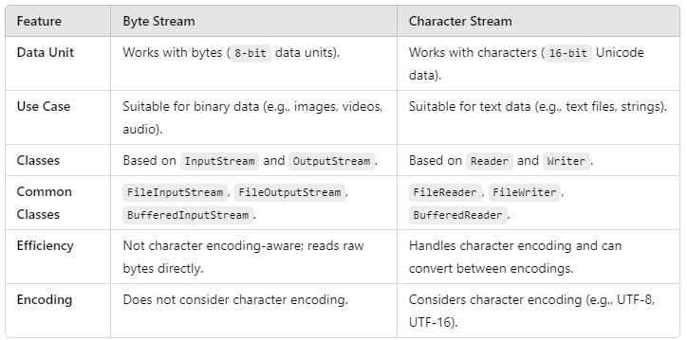

Key Differences Between Byte Stream and Character Stream

**When to Use Byte Stream**

* **Binary Data**: Use Byte Streams when dealing with binary data such as images, audio files, or video files where character encoding isn’t necessary.
* **Network Communication**: When sending or receiving raw bytes over network connections or when interacting with low-level data streams.
* **Serialization**: Use Byte Streams for serializing objects to binary format.

**When to Use Character Stream**

* **Text Data**: Use Character Streams when reading or writing text files or when handling character data in Unicode format.
* **Localized Text**: Use Character Streams when working with character data that needs proper encoding (such as UTF-8 or UTF-16).
* **Text-Based Protocols**: When dealing with protocols or APIs that exchange information in text format, Character Streams are more suitable.

**Difference between Microservice & Webservice:**

| **S.NO.** | **MICROSERVICES** | **WEBSERVICES** |
| --- | --- | --- |
| 01. | It is a software architecture, that can be implemented with web service. | It is just technology for providing services. |
| 02. | These are horizontal in approach and nature. | These are vertical in nature, i.e. in comparison to provider-consumer communication. |
| 03. | It is considered as an autonomous application designed for a single, specific service as a part of a large application. | It acts as a strategy to facilitate service availability across applications by a web interface. |
| 04. | Microservices are more complex and compact. | Web Services are simpler as compared to Microservice. |
| 05. | These are limited in sharing by bounded context. | Web Services allow the sharing of components. |

Microservices

<https://www.geeksforgeeks.org/java-interview-questions/>

**151**